**Experiment - 1**

**Name:Rhythm Kachhwaha**

**SAP:500107218**

**Batch - 4 AIML**

**Q1. Write a Python program to perform basic arithmetic operations (addition, subtraction, multiplication, division, and modulus) on two numbers.**

**Prompt the user to enter two numbers.**

**Perform the arithmetic operations and print the results.**

**Use appropriate operators and print formatting for clear output.**

num1 = float(input("Enter the first number: "))

num2 = float(input("Enter the second number: "))

addition = num1 + num2

subtraction = num1 - num2

multiplication = num1 * num2

division = num1 / num2

modulus = num1 % num2

print(f"Addition: {num1} + {num2} = {addition}")

print(f"Subtraction: {num1} - {num2} = {subtraction}")

print(f"Multiplication: {num1} * {num2} = {multiplication}")

print(f"Division: {num1} / {num2} = {division}")

print(f"Modulus: {num1} % {num2} = {modulus}")

Output:

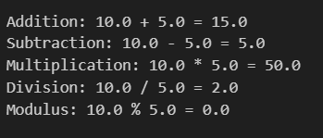

**Q2.Create variables of different data types (integer, float, string, boolean) and perform basic operations on them.**

**Assign values to variables of different data types.**

**Perform arithmetic operations on numeric data types.**

**Concatenate strings using the + operator.**

**Use logical operators to evaluate boolean expressions.**

#Q2

integer_var = 10

float_var = 5.5

string_var = "Hello"

boolean_var = True

#arithematic

sum_result = integer_var + float_var

diff_result = integer_var - float_var

product_result = integer_var * float_var

div_result = integer_var / float_var

# Concatenating strings

concatenated_string = string_var + " World"

# Using logical operators to evaluate boolean expressions

and_result = boolean_var and False

or_result = boolean_var or False

not_result = not boolean_var

# Printing the results

print(f"Integer value: {integer_var}")

print(f"Float value: {float_var}")

print(f"String value: {string_var}")

print(f"Boolean value: {boolean_var}\n")

print(f"Sum of integer and float: {sum_result}")

print(f"Difference between integer and float: {diff_result}")

print(f"Product of integer and float: {product_result}")

print(f"Division of integer by float: {div_result}\n")

print(f"Concatenated string: {concatenated_string}\n")

print(f"Boolean AND operation: {boolean_var} and False = {and_result}")

print(f"Boolean OR operation: {boolean_var} or False = {or_result}")

print(f"Boolean NOT operation: not {boolean_var} = {not_result}")

**Output:**

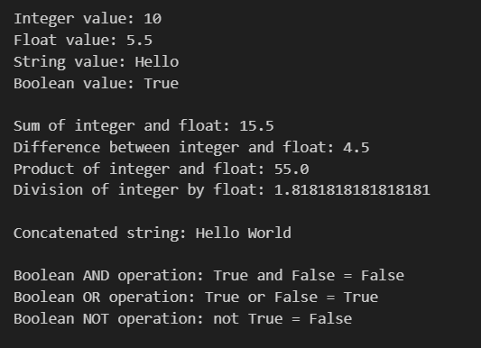

**Q3. Write a program to take user input, process it, and display the result.**

**Prompt the user to enter their name.**

**Greet the user using their name.**

**Calculate and print the user's age based on their birth year.**

#Q3

name = input("Enter your name")

print(f"Hello {name} , Good morning")

birthyear = int(input("Enter your birth-year"))

age = 2024 - birthyear

print(f"Your age is {age}")

**Output:**

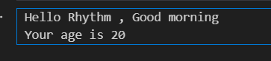

**Q4. Write a program to check if a number is even or odd.**

**Prompt the user to enter a number.**

**Use the modulus operator to determine if the number is even or odd.**

**Print the appropriate message.**

#Q4

num = int(input("Enter a number"))

if(num % 2 == 0):

    print(f"{num} is an even number")

else:

    print(f"{num} is an odd number")

**Output:**



**Q5. Write a program to print the numbers from 1 to 10 using both for and while loops.**

**Use a for loop to iterate through a range of numbers.**

**Use a while loop with a counter variable.**

#Q5

print("using for loop:")

for i in range(1,11):

    print(i)

print("using while loop:")

counter = 1

while counter<=10:

    print(counter)

    counter +=1

**Output:**

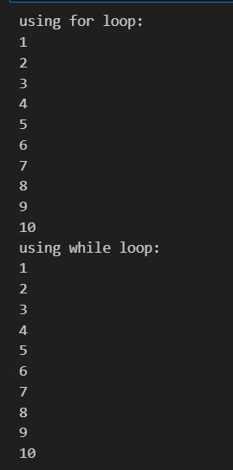

**Q6. Create a list, access elements, modify elements, and perform list operations.**

**Create a list of fruits.**

**Access elements using indexing.**

**Modify elements in the list.**

**Add and remove elements from the list.**

**Find the length of the list.**

**Sort the list in ascending and descending order.**

# List of fruits

fruits = ["apple", "banana", "mango", "orange"]

# Accessing element using indexing

print("Accessing element using indexing:")

print(f"Element at 0th index is {fruits[0]}:")

# Modifying element

print("\nModifying element 'banana' to 'pineapple' and returning the list:")

fruits[1] = "pineapple"

print(fruits)

# Adding elements

print("\nAdding more fruits to the list:")

fruits.append("strawberry")

print(fruits)

# Removing an element

print("\nRemoving the element at index 2 (mango):")

fruits.pop(2)

print(fruits)

# Length of the list

length = len(fruits)

print(f"\nThe length of the list is: {length}")

# Sorting in ascending order

print("\nSorting the list in ascending order:")

fruits.sort()  # Sorts in ascending order

print(fruits)

# Sorting in descending order

print("\nSorting the list in descending order:")

fruits.sort(reverse=True)  # Sorts in descending order

print(fruits)

**Output:**

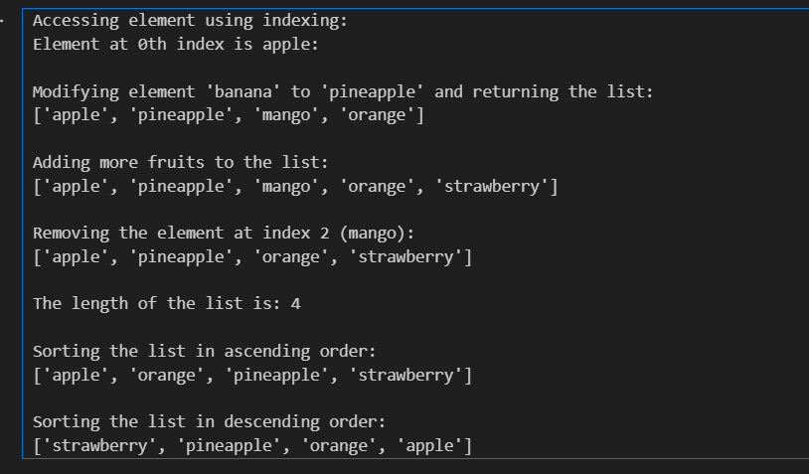

**Q7. Manipulate strings using various built-in functions.**

**Create a string variable and find the length of the string.**

**Convert the string to uppercase and lowercase.**

**Check if a substring exists in the string.**

**Split the string into a list of words.**

#Q7

# Create a string variable

my_string = "hello my name is Rhythm"

# 1. Find the length of the string

length = len(my_string)

print(f"Length of the string: {length}")

# 2. Convert the string to uppercase

uppercase_string = my_string.upper()

print(f"String in uppercase: {uppercase_string}")

# 3. Convert the string to lowercase

lowercase_string = my_string.lower()

print(f"String in lowercase: {lowercase_string}")

# 4. Check if a substring exists in the string

substring = "Rhythm"

if substring in my_string:

    print(f"'{substring}' exists in the string.")

else:

    print(f"'{substring}' does not exist in the string.")

# 5. Split the string into a list of words

words_list = my_string.split()

print(f"List of words: {words_list}")

**Output:**

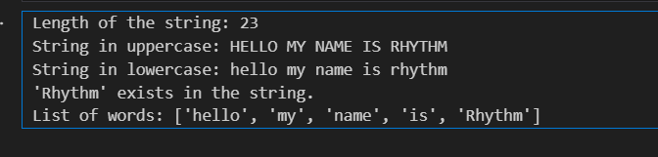

**Q8. Write a program to find the largest and smallest number in a list.**

#Q8

# List of numbers

numbers = [10, 24, 3, 57, 18, 6, 99, 1]

# Find the largest number

largest_number = max(numbers)

# Find the smallest number

smallest_number = min(numbers)

print(f"The largest number in the list is: {largest_number}")

print(f"The smallest number in the list is: {smallest_number}")

**Output:**

